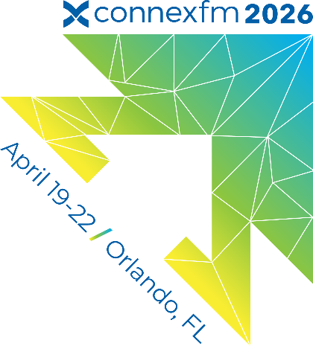

ConnexFM Team Exhibition Contact: Ginger Hayward-Bittner, CEM ; Director, Global Events

Direct 469-619-5976

Email sales@connexfm.com

ConnexFM 2026 National Conference & Tradeshow Exhibitor Information

[Exhibitor Console:](https://exhibitor.connexfm.com/connex2026/Public/e_Login.aspx?FromPage=e_ExhibitorConsole) if you need your password please email [sales@connexfm.com](mailto:sales@connexfm.com)

Use your exhibitor console to:

* Access the exhibitor service kit to order items for your booth
* View, download and manage invoices
* Update your exhibitor online profile info,
* **Beginning Mid-November register your team that will be in attendance so that they can pick up their access badges onsite by selecting  “Conference Registration” reserving your booth does not automatically grant access to your onsite team, you must also register them as attendees and book your housing once registration opens**

* **Order your booth materials with the Freeman Exhibitor Services kit** - Carpet or flooring of some type is required,  If ordering through our show contractor Freeman using the Exhibitor Service Kit in your console for any questions on booth ordering
* **Need help ordering or knowing what to order?** [View Exhibitor FAQ’s Here](https://www.freemanco.com/documents/faqs) -  Quick reference for answers to just about everything! You are not required to use Freeman for your booth item ordering needs, but carpet/flooring will still be required

Using Freeman for your booth materials needs and ordering as well as shipping needs and need assistance?

Phone: (888) 508-5054 (There is an option for a call back if you prefer not to hold.)

Text: (888) 508-5054

Chat: [Click here](https://us-east-2.protection.sophos.com?d=five9.com&u=&p=m&i=NjE0Y2I3NjNlMzUzYzkwZTdlMGRkMzk1&t=VVVpOU1sZ1lySE8xVzcvUHdnRTIwTjBYY0xudFNlUU9zQjAvVHhoU1hrOD0=&h=615e2a0691de4b1bad718d5ad8b7e8e0&s=AVNPUEhUT0NFTkNSWVBUSVZS5NAbDEFPXb_iyftt2ZmcbT2ZUXR4FU0JhGE9fNENoA)

* **Register your team and book your hotel**, You can begin registering your team as of December 10th using your online exhibitor console if you need any additional registration assistance please email [events@connexfm.com](mailto:events@connexfm.com) Again, reserving your booth space is step one, but you must still register your team members that will be onsite so that they can receive their access badges. Book your hotel as soon as possible if you want to stay at the Gaylord Rockies in the ConnexFM Room Block. The ConnexFM room block will sell out!
* **Ordering Electrical and Internet for your booth**- Electrical & Wi-Fi for your booth if needed are ordered through the Gaylord utilizing the exhibitor services kit . There is service in the hall, but it may be slow given it’s a shared network. If you have any web based presentations planned I recommend purchasing your own dedicated networking
* **Quick Connect**- As an exhibitor you have access to both days of the quick connect networking event.  Make sure your team is prepared!  You’ll pick up your access wristbands onsite at the Member Services Desk. Remember, only one person from your team is allowed in at a time so plan your strategy accordingly!
* **Shipping-** The Advanced Freight warehouse begins accepting shipments March 7th.  You can find all things needed, labels and all, in your exhibitor services kit if you’ll be shipping to the warehouse , warehouse deadline to receive shipment is **April 15th 2026**

For Exhibitor shipping needs and shipping quotes: [exhibit.transportation@freeman.com](mailto:exhibit.transportation@freeman.com) or via toll free number at 1- 800-995-3579 and a transportation agent will happily assist.

* I**nsurance**- It is required for all exhibitors to be insured. Send over a copy of your Certificate of Insurance if you haven’t already,  view sample [here](https://acrobat.adobe.com/id/urn:aaid:sc:VA6C2:8703b923-db62-4fa6-8cf9-f2af69543952). Please email your COI to [sales@connexfm.com](mailto:sales@connexfm.com). If you do not have insurance you can participate in the ConnexFM Exhibitor Liability Insurance program. Please visit the Exhibitor Knowledge hub for more information.
* **Exhibitor Appointed Contractors-** If you have an Exhibitor Appointed Contractor (EAC) that will be installing and dismantling your booth other than Freeman please fill out and email [the 2025 National Conference EAC form](https://acrobat.adobe.com/id/urn:aaid:sc:VA6C2:c1ce2647-df71-417b-b3c1-6e43b877281d) to sales@connexfm.com
* **Booth Food & Beverages-** If you will be ordering any food or beverages for your booth you can do so through your exhibitor services kit. All food and bev must be provided by the Gaylord Rockies Catering Menu, Outside food and beverages will not be permitted. Outside alcohol brought into the exhibit hall will be confiscated by hotel security. Do not bring any outside food and beverages to the exhibit hall floor.